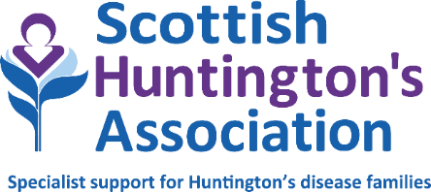

ADMINISTRATION / RESOURCE WORKER – Lanarkshire

Job title: Administration / Resource Worker

Hours: 24 hrs (negotiable)
Base: Hybrid. Mainly working from home but requirement to work at Hunter Health Centre East Kilbride and Airbles Road Clinic Motherwell occasionally.
Salary: £25, 178 pro rata
Reporting to: Senior Huntington’s Disease Specialist

Qualifications/skills: Experienced individual with excellent communication skills

Essential experience in Windows-based computer systems, including database and spreadsheets

Audio typing

NHS systems preferable

ROLE SUMMARY

To provide administrative assistance to the Senior Huntington’s Disease Specialist (SHDS) including the production of reports and collation of information and resources as required by the service.

MAIN DUTIES AND RESPONSIBILITIES

To develop and maintain efficient administrative systems in support of the Lanarkshire service

To assist Scottish Huntington’s Association to promote awareness of the needs and challenges faced by Huntington’s families through the provision of information as guided by the Senior HD Specialist.

To assist the Senior HD Specialist to maintain accurate records and statistical data as required by the service, using Windows-based computer systems including databases and spreadsheets

To assist the Senior HD Specialist to maintain accurate financial records as required by Scottish Huntington’s Association

To assist with the update of clinical activity and the input of clinical information to the Scottish Huntington’s Association database as specified by the Senior HD Specialist.

To assist in organisation of local and national study days and training sessions

To assist with mailshots, audit and service satisfaction surveys

In conjunction with the Senior HD Specialist, to develop a resource library of relevant, updated material relating to the client group

To communicate appropriately with clients, professional staff and other relevant agencies

This job description may be subject to review following discussion with the post holder and management of Scottish Huntington’s Association.

Notes:

This job outline reflects the main tasks and responsibilities discharged by the post holder at the present time, however Scottish Huntington’s Association reserves the right to alter or amend the content of this job outline to reflect changes to the job or services provided, while maintaining the overall character and level of responsibility for the post

Notwithstanding any information or statement described within this job outline, all duties must be carried out in a way that promotes equality of opportunity, dignity and respect for all individuals and which is consistent with Scottish Huntington’s Association’s stated policy on equal opportunities

The successful candidate will be subject to an Enhanced Disclosure for Protecting Vulnerable Groups. Having previous convictions will not automatically disbar you from working at Scottish Huntington’s Association (with the exception of offences against children or other vulnerable groups) and every case is taken on an individual basis

The duties and responsibilities of this post will be undertaken in accordance with the policies of Scottish Huntington’s Association

April 2026

